Didn’t work

http://www.disneyfoodblog.com/2010/08/05/disneylands-mint-julep-recipe/

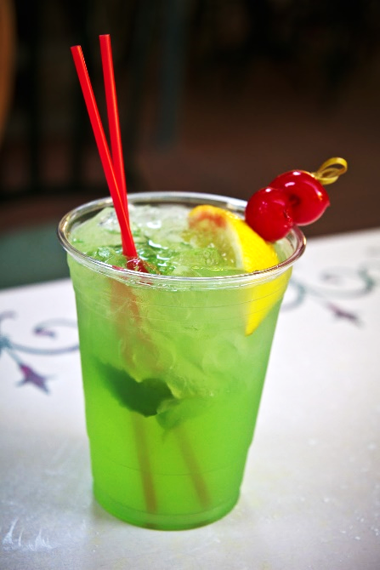
Disneyland's Mint Julep
By: AJ

I found this recipe over on the No.1 Disneyland Blog, which is a really fun site I’ve just discovered!

Yield - 2/3 gallon

Ingredients
- 1 cup sugar
- 3 cups club soda (or neuro drink, nat mtn dew)
- 3 tsp lime juice concentrate
- 6 Tbsp creme de menthe syrup (not liqueur) (or mint extract, yerba mate mint tea)
- 6 oz thawed lemonade concentrate
- garnish
- mint leaves
- pineapple slices
- maraschino cherries
- bamboo skewers

Method
- Dissolve sugar into club soda. Add lime juice and lemonade and bring to a boil. Remove from heat and add creme de menthe. Chill.
- To serve, combine 3 parts syrup to 5 parts water. Add mint, and skewer two pineapple slices and a cherry. Serve chilled (add ice cubes if necessary).

Didn’t work
Modified version
- Crème de menthe: sorghum syrup + neutral ice cream (or whipped topping) + mint tea
- Key lime la croix (optional)
- Key lime juice
- Lemonade (from whole lemons) (or orange juice)
- Garnish
  - Mint sprigs or leaves
  - Pineapple or lemon slices
  - Fresh cherries or strawberries
  - Umbrellas
https://savortheflavour.com/mint-julep-recipe-non-alcoholic/
https://www.atablefullofjoy.com/easy-mint-julep-inspired-by-disneyland-non-alcoholic/
https://www.allrecipes.com/recipe/104657/alcohol-free-mint-julep/
mint tea - instead of water
black (or green) tea - instead of soda (or ginger ale?)
peppermint oil - instead of extract

